Hairdressing & Barbering Scissor Scrappage Recycling Scheme
Quinn Hair and Beauty are the authorised distributor for KAMISORI scissors and QUINN hair tools in UK and Ireland and regularly see old hair scissors in hair salons or barber shops not correctly recycled as well as many sent for sharpening which are no longer suitable for sharpening which we then have to scrap recycle.

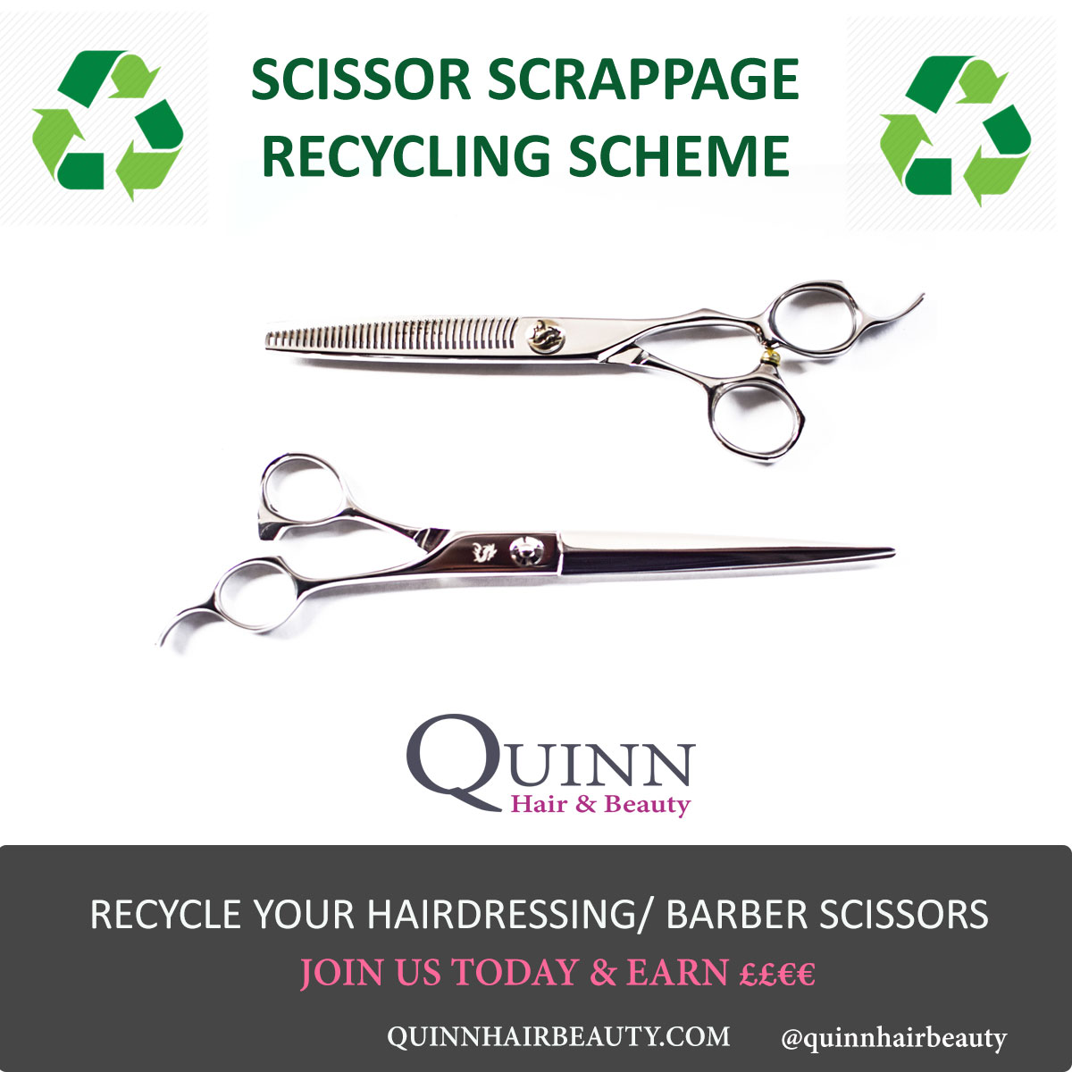
Recycle and Trade in Your Old Hairdressing Scissors and Barber Shears: UK and Ireland
We are working with a local scissor recycling centre in Newry, Northern Ireland to dispose safely of these hairdressing scissors and barber shears any that are in good enough condition we will service them and offer to local colleges/students throughout the UK and Northern Ireland/ Ireland.
We may also be able to collect valuable spares for scissors we are sent for servicing/ repair from those returned when we are repairing/ sharpening our scissors.
You will receive £12/€14 per scissor returned (cutting scissors or thinners). We accept any branded pair of professional steel hairdressing scissors or barber shears (but not household scissors).
You will receive a voucher for each pair of scissors or thinners/texturisers returned which can be used to purchase new scissors, hair/barber tools or accessories from Quinnhairbeauty.com.
If you want to take part in this important environmental initiative for the hairdressing and barbering industry please contact us and confirm the quantity of scissors you would like to recycle.

